Shabbos Stories for
Yom kippur 5777
Volume 8, Issue 3 10 Tishrei 5777/ October 12, 2016
Printed L’illuy nishmas Nechama bas R’ Noach, a”h

For a free subscription, please forward your request to keren18@juno.com

It Once Happened

Born on Yom Kippur

"I was born in Tel-Aviv on Yom Kippur. And on a Yom Kippur years later, I was again "born" somewhere in the Far East." So begins the interesting tale of Arnon G.:
My parents weren't religious in the usual sense of the word, but both of them were believers. I grew up on a foundation of a generalized belief in some sort of 'Being' that ran the world.
On holidays my father would take me, the eldest son, and my two brothers and sister to synagogue, each year a different one. He wanted to expose us to Jewish culture and to familiarize us with different communities and customs. And always, on Yom Kippur, my father would point out that it was my birthday.
On the Yom Kippur that I turned 13, I was called up to the Torah, and I recall that everyone was kidding around and joking that my parents "got away" with a cheap bar mitzva celebration, in that they didn't have to provide any food.
At around the age of 16 I started to undergo a personal crisis. I asked myself many questions. I argued with my teachers, my friends, and my parents. All these arguments only made me more confused. I was searching for meaning in life and couldn't find any.
The next few years were spent vacillating from one side to the other. I tried every fad that came along. I felt as if I were seeking some sort of clear path in life.
After the army I left on a tour of the world which was to last at least a year. I travelled around the United States and Europe and finally ended up in the Far East. I was drawn there primarily because of the mystical teachings and traditions which emanated from that part of the world. I thought that perhaps there I would find the answers to the questions I had about life.
An English girl I knew brought me to a particular sect which interested and excited me very much. Finally I was among people who deal with the real issues and questions and who looked for the way to draw nearer to what they called "the way." I had several powerful mystical experiences with them that brought me to the decision to become a permanent member of the sect.
They had a special ceremony for receiving new members. They would bring a big box full of various things, spread them all out on a red velvet carpet, and the person to be initiated into the sect would have to light some incense and swear allegiance to the sect and to its principles. Without knowing why, I found myself becoming repulsed by this ceremony.
The night before the ceremony I was trying unsuccessfully to fall asleep. Every time I closed my eyes I saw in front of me Jews wrapped up in talises, wearing kittels (white robes), and swaying to and fro in intense prayer. It was an early childhood memory of Yom Kippur. The scene kept repeating itself in my mind until suddenly the idea flashed into my head to check the calendar. I opened the calendar and froze: It was Yom Kippur!
That night I didn't sleep. Doubts and worries too great to bear tore through me. I decided to discuss my difficulties with the leader of the sect, a venerable old man with a pleasant face and a discerning eye. I told him my story, and when he heard that I was a Jew and that I was born on Yom Kippur, he started to shake his head from side to side, murmuring, "no, no." After a long silence he took hold of my hands, and said, "Return to Israel. Everything that we have is contained in Judaism!"
I returned to Israel and started to study about Judaism, to study the Torah and keep the commandments, and I finally found what I was looking for. That is why I say that I was born twice on Yom Kippur.

Reprinted from the Yom Kippur 5776 edition of the L’Chaim Weekly, a publication of the Lubavitch Youth Organization in Brooklyn, New York. Translated by Basha Majerczyk from Sichat Hashavua.

In Strange Site, Israeli Harley Davidson Riders Daven at the Kosel Before Yom Kippur
By Anav Silverman

Among the traditional knitted and velvet yarmulkas of those praying at the men’s section of the Western Wall last night, one particular group stood out with their Harley-Davidson leather vests and black bandanas.
An Israeli group of Harley-Davidson riders made their annual trip to Jerusalem, as part of the traditional pilgrimage that members of the motorcycle club makes to the Western Wall before every Yom Kippur, the holiest day of the year in Judaism. Holding onto their helmets and prayer books, the bikers arrived from all over Israel to pray at the Kotel on Sunday night, September 20.
The group attracted the attention of hundreds of prayer goers who converge at the Western Wall for the Jewish penitential prayers known as Selichot during the days leading up to Yom Kippur,. Hearing the roar of the Harley-Davidson motorcycles, the bikers were greeted by applause, camera flashes, and selfie requests.
We came to pray for forgiveness, health, and happiness for our family, friends and all of the people of Israel,” Arik Eliovich told Tazpit.
“It’s always amazing to ride through Jaffa Gate and go to the Kotel during this time of year,” added Eliovich, who hails from Tel Aviv and drove to Jerusalem with his wife, Mazal.
The couple have been riding motorcycles for 36 years and have traveled throughout Israel and have done a little bit of riding abroad as well.
Arik and Mazal are both members of Israel’s Harley Davidson Club, which is open to anyone who owns a Harley. According to Eliovich, there are about 170 members in the club. Throughout the year, the bikers participate in different group.
In Israel, there are approximately 800 owners of the iconic American Harley motorcycle, which was first manufactured in Milwaukee, Wisconsin in 1903.

Reprinted from last year’s Erev Yom Kippur (September 21, 2015) website of Matzav.com. The item was distributed by Tazpit News Agency.

Why the Boy in This
Photo Was Right
By Jay Michaelson

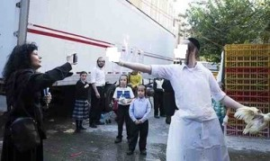

The following is excerpted from an article in the Forward by Jay Michaelson:

As Forward readers know, I have, on several occasions, criticized [the] ultra-Orthodox…
So, when a photo circulated this week of a Hasidic teenager, one hand grasping a chicken for the kaporos ritual, the other [expressing his displeasure with] an animal rights protester, one might think I’d join the chorus of criticism of this latest instance of Haredi misbehavior.
But I won’t do so.
In fact, the teenager is right, the animal rights protester is wrong, and my assorted liberal friends on social media who are approvingly sharing the photo (adding their own pious condemnations, of course) are even more wrong.
The trouble is that those who have lately taken to protesting kaporos are not doing so because of philosophical or theological objections – but in the name of animal rights. Like the campaigns to ban kosher slaughter, the drive against kaporos is ostensibly to prevent cruelty to animals – in this case, the unfortunate chicken.
But that is ludicrous – so ludicrous as to bely the animal rights activists’ claims themselves. Have these people ever been to a farm? Or, for that matter, a Latino neighborhood anywhere in New York? Chickens are routinely swung, thrown, kicked – I’m not saying any of this is justified, but I am saying that whatever suffering a chicken may experience in kaporos is chump change compared to practices that are commonplace everywhere chickens are eaten.
And they’re the lucky ones. In industrial farming in America, chickens often have their beaks scalded at birth to prevent them from pecking at one another. They live in appalling, cramped cages and are force-fed for their entire miserable lives. Disease is rampant, and chickens live in their own filth. And then finally, they are electrocuted, decapitated, or otherwise executed on conveyor belts.
For every one chicken waved over a hasid’s head in Brooklyn, literally a million suffer far, far more grievously in the American industrial agricultural system.
Oh, and then, thanks to our country’s outrageous attitude toward food waste, about half of them aren’t even eaten. Their body parts spoil, or nearly spoil, in supermarket refrigerator cases. Their barely-eaten carcasses are cleared away at hotels, restaurants, airplanes, conference centers – and then thrown in the trash rather than donated to soup kitchens, on the pretext of non-existent health regulations.
In fact, from an animal-rights, environmental, and food-justice point of view, the chicken that Hasidic teenager is holding is one of the luckiest, greenest, and most justly used farm animals on the planet.
So why are the protesters protesting?
Well, for one thing, kaporos is convenient. Crown Heights, Williamsburg, and Borough Park are all within biking distance of my apartment and those of Brooklyn animal rights activists. We don’t have to question the entire economic system that allows for our bubble of artisanal goods and affordable clothing, we don’t have to schlep down to Arkansas to protest Tyson Foods; I can just grab the 3 train and yell at Chabadniks.
But more importantly, kaporos is religious. And that’s what’s really bothering the do-gooder liberals who choose to spend their Septembers finding Hasidim to mock, deride, and ultimately judge.
If these animal rights activists wanted to protest the egregious violence our culture does to animals, they should stand outside not synagogues, but restaurants and grocery stores,: that mainstream which facilitates the industrial suffering and slaughter of chickens that was only marginally ameliorated by California’s recent legislation. But these backward Hasidim provide such an easy target: so superstitious, so weird, so “other.”
And yet, not too other. I can’t imagine any of the mostly-white English-speaking protesters standing outside carnicerias and protesting traditional Latin American methods of animal husbandry and slaughter.
But the Jews – well, they’re just right. Easy to mock, yet safe to mock.
If it seems I’m playing the anti-semitism card too casually here, read the comments and tweets accompanying the picture. “Omg… their hair!” “Finger to you, ugly, Jewish looser.” These are not from the activists themselves – in fact, one of them registered her horror at the anti-semitic comments on a thread I saw. But they are what invariably accompanies the scapegoating of Jews, whether by conservatives or liberals.
The great irony of those social media friends of mine? They’re criticizing religious superstition, but in such a judgmental, condescending and ignorant way as to seem dogmatic themselves.
Indeed, if the Hasid is making a scapegoat out of that chicken, progressives are making scapegoats out of the Hasid.
But, some of them might reply, it’s not just the chicken-waving – it’s also the finger. Isn’t this the height of hypocrisy, someone pretending to be religious but in fact being vulgar?
Actually, no. Sure, had the teenager been better media-trained, he wouldn’t have flipped off the activist taking pictures – not exactly public relations 101. There are also young children in the background; that’s not so great either.
But come on, he’s a kid. And this is New York. And while I don’t know if the activists were shouting or chanting anything, or just shooting video, it’s clear they weren’t there to admire the venerable Jewish ritual. They were there to protest, and the kid is telling them to [go away]. Not graceful, but not dissimilar to how I greeted the Westboro Baptist Church when they protested me one time. And not at all dissimilar, I suspect, from how most of us act, especially in the face of intense provocation.
No, what this is about is a naïve, ignorant view of what religious people are supposed to be like – especially religious Jews. Hasidim are meant to be quaint, charming, and deeply spiritual, like some sanitized Tevye the Milkman, or Yentl. They’re meant to pray at the Western Wall.
And, indeed, in some simplistic view of the world, spiritual people are all supposed to be kind, soft-spoken and gentle-hearted, lovers of protesters and poultry alike.
What a load of [garbage]. Spirituality isn’t about wearing Lululemon all the time: it’s confronting the beautiful and terrible realities of life head on, in the daytime and at night.
For all these reasons, I’d like to join this kid, who I’ll probably never meet, in giving [my criticism] to that whole thicket of ignorance and condescension: the assumptions that liberal ethics are the only ethics, the delusions of what religious people are supposed to be like, and, most of all, the huge self-delusion that a few dizzy chickens in Brooklyn represent a significant part of the effort to secure justice and compassion for non-human animals.
A little reflection might help, if we stop judging long enough to try.
Jay Michaelson is a contributing editor to the Forward.
{Matzav.com Newscenter}

Reprinted from the September 22, 2015 website of Matzav.com

A 49-Hour Fast
By Rabbi Yaakov Asher Sinclair

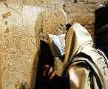

Can you imagine what it must be like for Yom Kippur, the Day of Atonement, to last two days? For most of us 25 hours of fasting is quite enough. But during the Second World War, there were people who fasted for 49 hours – two days of Yom Kippur.
When the Germans invaded Eastern Europe during the Second World War, the Mir Yeshiva made a miraculous escape across Europe and Asia to Kobe in Japan. However, when the Yamim Noraim approached, they were faced with a dilemma…
Up till the time of Hillel II, the date of the festivals, Pesach, Shavuos, Succos and Rosh Hashana were established via testimony based on the sighting of the new moon. The new month was declared in Yerushalayim, and it would take many days for the news to reach the furthest outposts of Jewish settlement. Those outlying communities would observe two days of Pesach and Succos etc., and thus they would be sure of observing the festival on the correct day, no matter which day had been sanctified in Yerushalayim as the new moon.
Until the era of Abaye and Rava, the months were still established by sighting. However, from their time onward, the date of the New Moon was established by calculations alone. These computations were given to Moshe at Sinai, and provided for the fixing of the beginning of each month throughout the possible span of world history. Thus all the lengths of all future months in exile were now fixed.
So why is then that if you’re in New York or London or Paris, you’re still keeping two days of Yom Tov? If the calendar is fixed and we know exactly which day is Yom Tov and which isn’t, why can’t we all keep just one day?
The answer is that our sages made a law that we should continue to observe the two days of Yom Tov as was the custom of our forefathers.
However, when our Sages mandated the continued observance of the two-day Yom Tov in the Diaspora as a continuation of the traditions of our forebears, they deliberately omitted a two-day Yom Kippur because it would be dangerous for some people to fast for such a long period.
However, the Mir Yeshiva in Kobe was faced with a different situation: The omission of the sages’ decree to fast two days of Yom Kippur was because we are certain on which day Yom Kippur occurs. However, Japan is close to the International Date Line, (a longitudinal line which lies 180° from Greenwich) and thus there was a real doubt as to which day it was. For this reason, there were those of the Mir Yeshiva who felt compelled to fast for two days. And even others who were less strong, while they could not observe the fast itself, commemorated all the other aspects of this holiest day(s) of the year.
Sources: Rambam, Hilchos Yom Tov, ch. 1; Hilchos Kiddush Hachodesh, ch. 5
“Escape to Shanghai”; Rabbi Mordechai Becher

Reprinted from the September 22, 2015 edition of Matzav.com The article originally appeared in OHRNET, the Ohr Somayach Torah Magazine of the Internet.
Yom Kippur in a
Buddhist Monastery
By Yitzhak Bronstein

I thought I’d left Judaism behind during my spiritual retreat in India. Think again.

I settled into my cushion on the floor of the gompa—meditation hall—as my intensive course in Tibetan Buddhism was about to begin, a month into my second backpacking trip to India in as many years. The previous day was Rosh Hashanah, but that wasn’t on my radar. I was here to move forward and delve into a new spiritual practice, something entirely unrelated to my Orthodox Jewish upbringing.
Hours earlier, 80 of us arrived at the meditation center and confirmed our willingness to adhere to the center’s monastic-like guidelines, including forfeiting all electronics, non-religious literature, and the right to speak for 23 hours each day. A nun in maroon robes oriented us to the course’s daily schedule—three meditation sessions, two lectures, and a single hour-long discussion group—and read off various miscellaneous policies from worn printouts.

“How Many Participants would be
Observing the Jewish Festival?”
When it seemed like the orientation had concluded, she lifted her eyes from the list of guidelines and asked us the last question I could’ve anticipated: How many participants would be observing the Jewish festival (“was it Passover?”) and fasting on the last day of the course? Remarkably, in this room full of Buddha statues, Tibetan art, and translated texts, a quarter of the participants—mostly Israeli backpackers—unabashedly raised their hands. Even more remarkably, I surprised myself by lifting my own, too.
So much for leaving Judaism behind.
After nearly two decades of Orthodox upbringing, I spent two years studying at a yeshiva in the West Bank. Soon after returning to New York for college after yeshiva, however, I became disillusioned with Orthodox dogma and turned off by the community’s public stances—and at times its even more telling silences—on social, political, and environmental issues about which I felt strongly. In short time, I came to see Orthodoxy as something judgmental, untrue, and irrelevant. Still thirsty for a spiritual outlet, I turned to unorthodox alternatives: environmentalism, meditation, Eastern-influenced mystics, and traveling abroad.
Last year, my spiritual quest led me to Dharamsala. Nestled in the foothills of the Indian Himalayas, the town is most famous for being the home of the Dalai Lama and headquarters of the exiled Tibetan parliament. The stunning scenery and laid-back vibes make the district a definite highlight on the “Hummus Trail”—the unofficial list of destinations on the Indian Subcontinent to which Israeli travelers flock after completing their stints in the military—compelling restaurants, guesthouses, and travel agencies in the surrounding villages to advertise bargain deals in conspicuous Hebrew letters.

Far from the Orthodox Home
In which I was Raised
Many local businesses cater to tourists’ spirituality-seeking bent, and amateur painted signs offering courses in meditation, yoga, and Buddhism are plastered on walls everywhere. Far from the Orthodox home in which I was raised and in the midst of a seven-month solo journey of self-discovery, I felt inspired to sign up for an intensive eight-day course at a Buddhist meditation center in a nearby village. Attracted by both Buddhist philosophy and a desire to immerse myself in contemplative spirituality, I had barely noticed how the course overlapped with the Jewish calendar—beginning the day after Rosh Hashanah and concluding on Yom Kippur itself.
Waiting anxiously in the gompa, I reflected on how far I had come from the sense of absolute certainty that defined me during my two years as a yeshiva student in Israel. The world of right and wrong, of true and false, which was so intuitive to me several years prior in the yeshiva’s study hall, now seemed not only lost forever, but undesirable.
Over the next several days, we studied the foundations of Buddhist dogma and sat in meditation focused on our breathing and practicing visualizations. But within my own mind seasoned with years of studying in traditional American and Israeli yeshivas, I couldn’t help but notice parallels and contrasts between Tibetan Buddhism and Orthodox Judaism.

Reflecting on the Jewish Notion of Teshuva
While other students recorded the Buddhist definition of karma dictated by our teacher into their notebooks, I wondered whether the Jewish notion of teshuva signified a competing paradigm that granted more self-empowerment to those seeking a fresh start. When we were instructed on how to meditate in the lotus position and the importance of maintaining awareness of our posture, I couldn’t help but think of the years I had spent hunched over the Talmud without giving a moment’s notice to my physical body.
And no one who has spent time in a yeshiva could observe energetic duos of Tibetan monks debating without associating the practice with the unique chevruta system in which yeshiva students study in pairs. It fascinated me how both Jews and Tibetans had blurred the lines between their religious and cultural identities over the centuries, and how language, food, festivals, and land had all necessarily become intertwined with spiritual practice.
Perhaps the most attractive element of Tibetan Buddhism, as explained to us, was its remarkable sense of religious pluralism. In large measure due to the Dalai Lama’s ironclad adherence to pluralistic principles, Tibetan Buddhists insist on the truth of all major religions and urge Western spiritual seekers to try reaching fulfillment through their original spiritual traditions rather than adopting Buddhism. Much more than insincere posturing, the center’s commitment to religious pluralism became palpably apparent when Yom Kippur rolled around.

Dinner was Rescheduled to
Accommodate those Jews Fasting
The monk leading our course announced the day before Yom Kippur that dinner would be rescheduled so that those of us fasting would be able to eat the traditional last meal before sundown. It was a heartwarming gesture by itself, and we noticed upon entering the dining room that a table laden with falafel, hummus, and Israeli salad had been sponsored and prepared for us. Given the meager assets of the resident clergy, this humble offering was rightfully perceived as a stunning display of generosity and respect.
We were repeatedly told that we could do whatever was necessary to observe Yom Kippur, and the center bent over backward to ensure that we were comfortable. When a participant asked about ways to observe the festival, our teacher responded humbly, “It’s your day; it’s your ritual,” and that we shouldn’t do anything that would make us feel uncomfortable.
One recurring theme that struck me throughout the course was the constant reminder by the teachers that our attitude to their tradition—or any tradition, for that matter—shouldn’t be take-it-or-leave-it. After all, there may be certain concepts that seem foreign to the point of outlandish, but that shouldn’t stop us from integrating the principles that do speak to us into our lives. Over the eight days, I began to see the wisdom of this perspective, stretching the application of the concept to my attitude toward Judaism.
Unsurprisingly, in the context of a Buddhist meditation center, situations did arise that could have compromised one’s observance of Yom Kippur. For example, on the last evening of the course there was a ritual in which each participant lit a candle and placed it on one of the stupas, dome-shaped shrines dedicated to the Buddha.
A young Israeli woman expressed her discomfort with lighting a candle after sundown on Yom Kippur, and a discussion began on how we could be accommodated. One participant suggested that rather than kindling a flame, we could write a note instead, but, alas, that wouldn’t work—writing is forbidden on Yom Kippur, too. Maybe we could just say an oral prayer instead of lighting a candle, another proposed.

Talmudic Discussion on How to Worship an Idol
While suggestions were raised and rejected, the irony seemed to be lost on everyone. Here we were, a roomful of Jews and gentiles sitting in northern India and having a Talmudic discussion on how to worship an idol of the Buddha—in clear transgression of one of Judaism’s cardinal sins—without violating any of the legal minutiae of Yom Kippur. The obvious contradictions were ignored as we struggled to create a sense of harmony between two ancient religions and within our own hearts…
The course ended the following day with several hours still left before the conclusion of Yom Kippur. With a Chabad house just a short distance away from the meditation center—this is what it means to be on the Hummus Trail—I decided to walk over in time for the afternoon service. The red robes of the monks were replaced with black-and-white Hasidic garb, the Buddhist architecture swapped for an exact replica of 770 Eastern Parkway, and the portraits of the 14th Dalai Lama were switched to similarly oversized photographs of the seventh Lubavitcher Rebbe.

Given a Yarmulke and Called up for an Aliyah
In classic Chabad style, I was immediately given a yarmulke, called up to the Torah for an aliyah, and made to feel at home. I was an insider once again, far more familiar with the texts and rituals in the Orthodox synagogue than I had been while sitting in the Buddhist meditation hall.
My familiarity allowed me to notice subtleties that I otherwise might’ve missed, such as how the mechitza separating men and women created a constricting feeling that had been absent from the egalitarian meditation hall; and how the rabbi’s boisterous children running around were more distracting—and even somewhat refreshing—given the childless, monastic environment from which I had come.
Differences between the prayers were even more apparent: All week I had been uttering universal prayers for the benefit of all sentient beings in line with the Tibetan tradition—but the liturgy was now uncomfortably centered on the well- being of the Jewish people. That traditional Jewish liturgy is particularistic is true throughout the year, but it’s even more manifest in the prayers added on the High Holidays.
When the sun went down and the stars came out, the concluding shofar blast echoed off the surrounding Himalayan peaks. And as we danced in a circle and sang “next year in Jerusalem,” the Dalai Lama’s opinion that spiritual seekers should first aim to preserve the religion of their ancestors started to make more sense.
Discovery Judaism as something
Beautiful, Alive and Unique
This Yom Kippur experience turned out to be the most powerful of mine in recent memory. Observing the holiday in the context of another religion allowed me to see Judaism not through a prism of truth or falsehood, but as something operating on completely different planes: beautiful, alive, unique.
Walking back to my room from the Chabad house, I realized that I was neither here nor there, that I hadn’t left Orthodoxy to simply adopt another organized religion nor would I ever feel completely at home in a traditional synagogue.
Feeling a sense of resentment toward Westerners who blithely adopt Buddhist practices hook, line, and sinker, I understood that while I’m attracted to ritual and spiritual meaning, I was not interested in trading one system of thought for another. For good or for bad, I am a wandering Jew and destined to forge my own way forward…

Excerpted from the Tablet Magazine email of September 22, 2015.

A Lost Yom Kippur Experience

In 1967 the winds of war settled over Israel. Egypt, Jordan and Syria joined together with the intent of chas v’chalila destroying the Nation of Israel and the situation was very severe.
There was a boy from the United States studying in the Ponovitch Yeshiva. He was very nervous about the upcoming war and even his family was nervous about his situation, and they sent him a telegram requesting that he return to America.
The young man went to the home of the Rosh HaYeshiva, HaGaon Rebbe Shmuel Rozovsky, zt”l, and asked for his advice. What should he do? Should he fly back to his family in America or remain in Eretz Yisroel?
The Rosh HaYeshiva listened, thought about it, and responded: “Remain in Eretz Yisroel so that you do not lose out on great things.”
In the end, the young man could not overcome his fears, and under pressure from his family, he returned to America. On 26 Iyar 5727, June 5, 1967, war broke out. As is well known, great miracles occurred and within six days the Holy One, Blessed is He, brought the Nation of Israel victory and salvation.
After the winds of war subsided, the young man returned to the Yeshiva, and he approached the office of the Rosh HaYeshiva. The Rosh HaYeshiva greeted him warmly and with love, and the young man asked: “Honorable Rosh HaYeshiva, what did I miss, now that I did not stay in Eretz Yisroel?”
HaGaon Rebbe Shmuel Rozovsky, zt”l, replied: “You lost out on much. You missed the sirens. Every siren that was heard in our holy land was comparable to Yom Kippur itself. In your entire life you will not be able to celebrate so many Yom Kippurs as we did in such a short time!” (Chashukei Chemed, Nedarim)

Reprinted from the Yom Kippur 5776 email of Torah U’Tefillah: A Collection of Inspiring Insights compiled by Rabbi Yehuda Winzelberg.
Higher Than Heaven
By Shula Bryski
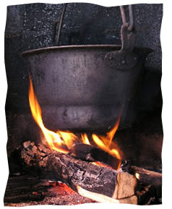

It was the night of Yom Kippur, the holiest time of the year.
As all the Jews were gathering in shul anxiously awaiting their rebbe’s arrival to begin the prayer services, Rabbi Shneur Zalman, also known as the Alter Rebbe, mysteriously left the small European village.
Some of his devoted and admiring chassidim speculated that their beloved leader went to heaven, connecting to G-d and His angels in the heavenly spheres in preparation for this holy time.
Where was their beloved leader?
As the Rebbe’s chassidim waited worriedly for him to arrive, he was climbing deep into the woods, with a sack on his back, to chop down wood.
They later learned that he then proceeded to bring the firewood and the sack into the lonely little house of an impoverished widow who had just given birth and her five small children. Saving a life is so important, that chopping wood and creating fire—normally forbidden on the holy day—are permitted.
No task was beneath this great Torah scholar as he created a blazing fire in the fireplace, unpacked the food and clothes from the sack, lovingly fed the children and left the woman with many kind and caring words.
Perhaps we could say that the Alter Rebbe went to a place even higher than heaven.
What is true goodness? What is true giving?
Judaism gently teaches us through the stories of the scroll that true goodness is not carried out in a blaze of glory.
True goodness and giving often involves nurturing and caring in little ways that go unseen.
Often when it’s hard.
Often when it hurts.
Often when it’s not really “my job.”
Impacting this world is not reserved for the knight in shining armor, for the airbrushed faces of Hollywood.
It is the responsibility and right of every one of us—with all of our talents and strengths, and yes, with all of our weaknesses.
We, and our loved ones, are immortalized long after we are gone, through the kind acts on this earth—the comforting whisper to a frightened child, the mending of a broken heart, the giving of charity when we need to dig deep, the patience and forbearance to a cantankerous relative, the nourishing home-cooked meal delivered with love . . .
It is through this goodness and giving that we touch the divine, ascending higher than heaven.

Reprinted from the website of Chabad.Org

A Cancer Survivor's Yom Kippur: With a Surprise Lesson to Carry With…
By Bentzi Sasson

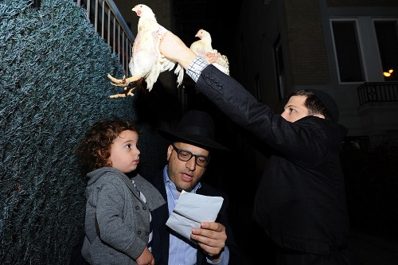
Performing “Kapparot” with my son prior to Yom Kippur. (Credit: Mendi Hechtman)

Yom Kippur 5775. The giant sanctuary at Lubavitch World Headquarters in the Crown Heights neighborhood of Brooklyn, N.Y., was beyond full. The climax of the day—the final Neilah prayer—was beginning, and the atmosphere in theRebbe’s synagogue was growing more and more intense.
I found myself standing alone on the high Torah reading platform in the center of the synagogue, completely covered in my tallit, trying as hard as I could to be as inconspicuous as possible. Around me, thousands of people were standing pressed together like sardines. I saw that each and every individual was trying his utmost to use the closing moments of this holiest of days for heartfelt prayer and introspection, pouring out their hearts before their Father in Heaven.
The words had added meaning for me this year. I read and I sobbed. I tried to wipe away the tears, but I could do nothing to stop the powerful sobs from racking my body. Standing above a sea of people crying out the words of the prayers caused me to dissolve in a sea of teary emotion.
* * *
It’s been five months since the dark day I was told that I had cancer. During those months, I underwent invasive treatments that have changed my life forever. In the beginning, it was all about fear of the unknown, dreading what lay ahead. Afterward, it was the regimen of chemotherapy that left me broken, a shell of my former self.
Three months of massive treatments with countless side effects: pain, suffering, despair, depression. My physical appearance changed as well. The hair on my head began to fall out, as did the beard I’d grown since I was a teenager. My face became pale, and my eyebrows and eyelashes disappeared. By the end, I was left with no hair at all.
From the very beginning, I knew that the only way I’d come out on top was to keep positive and maintain my faith, following the Chassidic adage: “Think good, and it will be good.” And I followed through to the best of my abilities. I made sure to attend prayers as often as possible, to speak to my friends and smile frequently. Even as strangers averted their gaze, and even as friends of mine walked past without recognizing me, I made sure to keep positive.
Thankfully, I was surrounded by loving family and loyal friends. They did whatever they could—and more—to support me, to give me strength and to help me stay on course. My wife, Devorah Leah, and my three young children were the light at the end of tunnel that kept me focused and positive through the darkest of moments.
Just a few days before Rosh Hashanah, I received the sweetest news: The treatment had done its work, and I was completely cancer-free. I smiled from ear to ear, like I had not smiled in many months.
Yom Kippur came, and my body was still battling the massive doses of toxins that had destroyed the cancer. I was afraid of what 25 hours with no food or water would do to me. I had already been admitted once due to dehydration and did not want to repeat the experience.
But not to fast on Yom Kippur? Unthinkable.
After speaking to a number of rabbis, it became apparent that the most important thing on Yom Kippur was not to eat or drink, even if would come at the expense of synagogue attendance. They advised me to stay home and rest up as much as possible for the duration of the fast.
I wasn’t thrilled by the prospect. On one hand, I wanted to pray with everyone else—to soak up the special atmosphere that pervades the synagogue. After all that I had experienced, I felt I needed that extra jolt of inspiration. On the other hand, I also realized that I needed to care for my body.
At the end, I decided to stay home and make the best of my situation. There was just no way that I could risk the crushing crowds that converged on shul during the holidays.

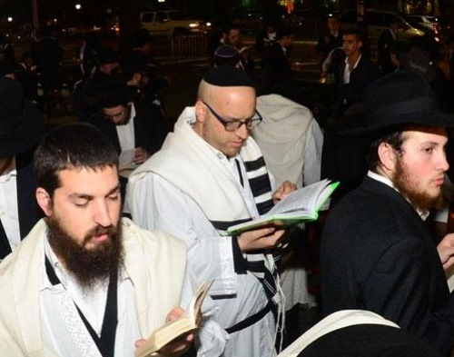
Reciting "Kiddush Levanah" (Sanctification of the Moon) after Yom Kippur. (Photo: Meir Dahan)

As the holy day wore on, my heart became heavier and heavier. I yearned to be with everyone else, to pray, to sing to feel spirituality so tangible you can almost touch it with your finger.
Suddenly, the door of my home opened, and there was my dear brother, Shmuel.
Knowing how I felt, he decided to ask the synagogue officers if they could make a special allowance for me. After the Musaf prayer, when there is a short break in the services, he asked if I could perhaps be allowed to stand alone on the Torah reading platform in the center of the synagogue for the closing portions of the day’s service, explaining that I’d otherwise not be able to attend.
With the assurance that an exception would indeed be made, my brother ran to my house to share the news. I was so happy! I was afraid, too, but I recognized that this was a unique opportunity that had opened up just for me. And I decided to go for it.
And so I found myself towering above thousands of my peers in the synagogue that is the heart and soul of the Chabad-Lubavitch movement. I did not look like a typical Chassid. My beard was just beginning to grow back, and I knew that people would be gawking, so I decided to drape my tallit over my head and create a safe space for me to be alone with my Creator.

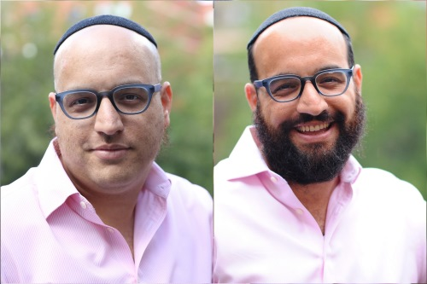
Photo: Mendi Hechtman

And there I was, sobbing into the woolen folds of my tallit, overcome by the experiences of the past months. As the memories flowed freely, they merged with the prayers swirling around me. The haunting melody of Avinu Malkeinu (“Our Father, Our King”) being sung by the entire congregation was powerful enough to shake the strongest of edifices, and I was far from strong at that moment.
A half-hour after the fast had ended, I found myself home, gratified and thankful to G-d for giving me the strength to complete the fast and pray among my fellow Chassidim.
* * *
A few days later, I step into my office and meet my friend and co-worker, Velvel. As he approaches, he says: “Bentzi, there is something I must tell you.”
“As the prayers were coming to a close on Yom Kippur,” he begins, “I felt a tap on my shoulder. I turned around and came face-to-face with an acquaintance of mine. He’s gesturing to the reading platform where you were standing and muttering, ‘Look where things have come to. There he is on the very same platform where the Rebbe would stand on Yom Kippur, shamelessly flaunting his shaved face. I can tell he’s not just a visitor. He looks like he grew up here, and he should know better than that.’
“I was shocked,” my friend continued. “I knew what you went through, and I couldn’t believe that someone would judge you so callously. Finally, I managed to reply: ‘You should just know that the fellow on the platform is a friend of mine, and I wish you that you never go through what he went through this year.’ He still didn’t get it, so I told him how you were less than a month after chemotherapy and your stubble was actually the first beginnings of what you hoped would soon be the luxurious flowing beard you had sported your entire adult life.
“I then turned to him and told him, you just learned the best lesson you possibly could this Yom Kippur. Never ever judge anyone. You never know what’s going on in someone else’s life.’ ”
It took me a few minutes to recover from the magnitude of what he had told me. When I finally managed to stand up, I knew what my New Year’s resolution would be as well: never to judge anyone!

Reprinted from the website of Chabad.Org

Shabbos Stories for
Yom kippur 5778
Volume 9, Issue 3 10 Tishrei 5778/ September 30, 2017
Printed L’illuy nishmas Nechama bas R’ Noach, a”h

For a free subscription, please forward your request to keren18@juno.com

“G-d Took Away My Son, Now Whatever He Says I Do the Opposite!”
By Naamah Green

But after he smoked a cigarette on Yom Kippur G-d brought him back anyway and gave him the greatest gift

Rabbi Zilbershtein shares an amazing story he was part of:
“In one of my flights out of Israel I sat next to a Mr. Weinstein who was obviously Jewish. I was curious about him. He had a non-kosher meal with his name Mr. Weinstein on it and I was wondering why he would want to eat a non-kosher meal. So when he finished eating I turned to him."
“Excuse me sir I’m not trying to be brazen or hurt you or anything like that but can I ask you a question?”
“Sure!” The man answered.
I asked: “Are you aware that you can order a kosher meal on flights like these?”
He looked at me and said tersely: “I don’t eat Kosher!”
So I asked back “what do you mean? That you eat kosher at home but not out of the house or that you don’t consider eating kosher something important?” “No I don’t eat kosher for that is my free choice!” He said with vehemence. “I don’t do any mitzvoth; do you want to know why?” he asked.

"I felt he was about to unburden something in his heart, so I said yes. He started in a broken voice: “It was my son… the last thing that broke me. I held on the whole time in the concentration camp until one day when I couldn’t anymore. In the camp I had one sole ambition; that my son Katriel Menachem should survive. His mother and all his brothers and sisters were all taken away but my son and I were going to live. I was certain of this”.
“One day we were in a roll call in a place that had secret doors to an area used for mass hangings. My son squeezed my hand so hard from fear he cut off blood circulation to it. We started to flee from the line of fire and his hand slipped out of mine and he disappeared. Later someone told me he saw a soldier take him and shoot him.”
Mr. Weinstein wiped away his tears as his voice rose in anger: “G-d took away all of my children. Now whatever G-d says, I do the opposite! I want nothing to do with His mitzvoth!”
Rabbi Zilbershtein continues: “I was so shocked by his story I had nothing to say and for six hours I sat totally silent next to Mr. Weinstein till we got to Houston and we each went our own way.”
“I never dreamed I’d see Mr. Weinstein again but four years later on Yom Kippur I was a guest in the Meah Shearim neighborhood. I walked out of the synagogue to refresh myself and breathe some fresh air into my lungs when I saw a strange sight. A man sitting on a Meah Shearim bench of all places was smoking a cigarette on Yom Kippur of all days!”
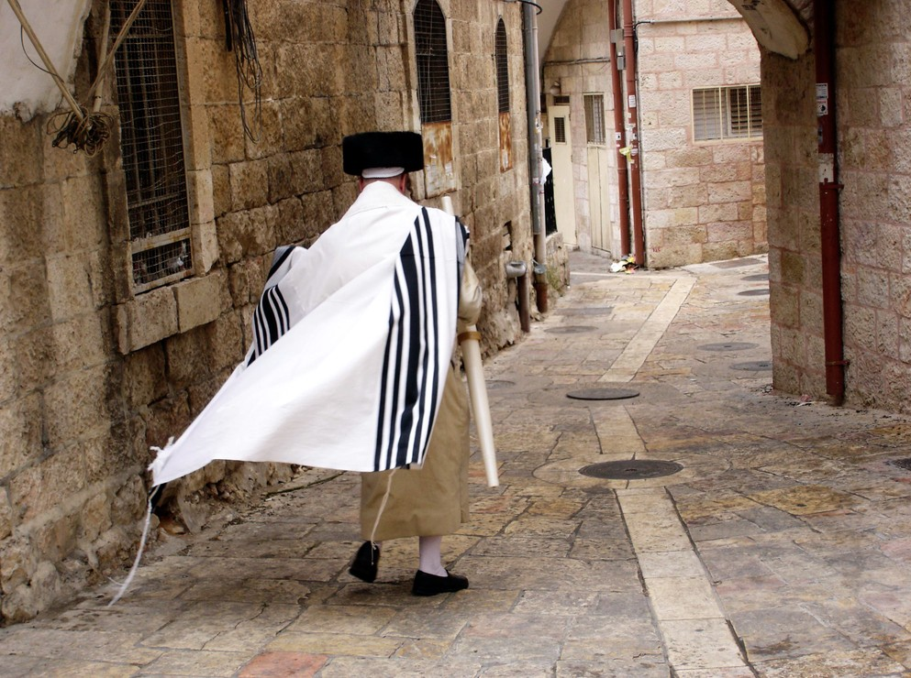

“But then I did a double take… it was Mr. Weinstein! I went over to him and said: “Here we are meeting again. Isn’t it funny how life brings people together and you wonder why they were put together? What message is hiding behind this? I’m sure you know today is Yom Kippur and in a few minutes they will be saying Yizkor to remember the loved ones no longer with us.
“Come with me and during Yizkor mention your son’s name to remember him and pray for his soul. This might be your only opportunity to mention his name. Don’t you want his name to be heard in the Heavenly Courts?”
“His eyes filled with tears, I hugged him and we locked arms and went into the synagogue near the cantor. We asked him to make a special memorial prayer for Mr. Weinstein’s son. Mr. Weinstein leaned on the cantor’s stand and whispered his son’s name to the cantor: “Katriel Menachem ben Yecheskel Shraga” he said.
“The cantor turned white and he broke out in a sweat, his eyes were bulging as if they’d pop out! He turned to us and in a choked voice cried, “Abba” (father) and fell down in a faint.”
Rabbi Zilbershtein concludes: “This is a wondrous story of how G-d guides the world above the natural and “one who comes to purify (himself) gets Divine assistance'. Mr. Weinstein made but a small gesture to come to synagogue on Yom Kippur (after having a cigarette!) and merited something unbelievable. G-d always watches over us and He is waiting for the smallest gesture on our part for Him. Look at the good you get in return!”

Reprinted from the Parshat Shelach email of Hidabrut.

Why Rav Chaim Ozer Had
To Leave Town in-between
The Yomim Noraim

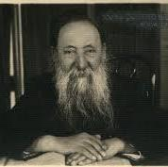

Rav Chaim Ozer Grodzinsky (1863-1940), OB”M, was the Rav of Vilna, and the recognized leader of the Jewish people in Europe after the Chafetz Chaim passed on to the Next World.
Once, he became sick during the High Holidays and the doctors told him to go to a health spa. Rav Chaim Ozer wasn’t so thrilled because he wanted to be with his people. Instead, he was in the middle of nowhere (spiritually) with barely a minyan to speak of.
The Shabbos between Rosh Hashanah and Yom Kippur, a man walked into the shul there. Rav Chaim Ozer asked him what he was doing there. The man replied, “My brother died, and left a wife and several children. So, I’m going over to St. Petersburg in order to marry her and raise the children.”
Rav Chaim Ozer was horrified and told the man that he can’t do that Halachically. The man countered with, “Well, Rabbi, this is the Mitzvah of Yibum that I’m doing!”
Rav Chaim Ozer explained to him that Yibum (Levirate Marriage) is only allowed when the widow has no children; otherwise, it’s considered a very serious transgression: “You would get Kores (spiritual cutting off) and the children the two of you have would be Mamzerim offspring of an ‘incest’ relationship.”
The man was not impressed, even after Rav Chaim Ozer showed him evidence from the Torah.
“I don’t know about Pesukim/verses,” the man sneered. “I’ll tell you, if the Rabbi of Vilna - that big Torah center - would say I shouldn’t do it, then I wouldn’t do it. Otherwise, I’m going to St. Petersburg!”
Rav Chaim Ozer smiled and said, “Well then, let me introduce myself. I’m Rabbi Chaim Ozer Grodzenski, Rav of Vilna.”
Finally, Rav Chaim Ozer understood why Hashem directed him to a health spa – so that he would encounter this man and prevent a tragedy from happening to a Jewish family.
Comment: This week’s portion goes into an in-depth discussion about how one has to stay away from certain relationships (such as with close relatives). Never will the Evil Inclination tempt a person and tell him it’s a sin, no matter how repulsive such a union would be.
Instead, it will sometimes tell him that it’s a Mitzvah (like the man in the story was convinced). No matter how lofty a level the person reaches, the Yetzer Horah will try to sneak his evil designs into one’s heart.
We read these verses on Yom Kippur afternoon, when we have the high-and-mighty feeling that we will never sin again, to underscore Hillel’s teaching, “Don’t trust yourself until the day you die.” (Pirkei Avos 2:4).

Reprinted from the Acharei Mos 5776 email of Reb Mendel Berlin’s Torah Sweets Weekly.

What is the Latest that
One is Permitted to Eat
On Erev Yom Kippur?

QUESTION. What is the latest that one is permitted to eat on erev Yom Kippur? May one continue eating right up until shkia (sunset)?

ANSWER. Although Yom Kippur is on the tenth day of the Hebrew month of Tishrei, the Torah (Vayikra 23:32) writes that Yom Kippur should be observed beginning the ninth of Tishrei towards evening. From this, the Talmud (Yoma 81b) infers that there is a mitzvah to add to the fast of Yom Kippur while it is still day time. Although Shulchan Aruch (Orach Chaim 608:1) writes that there is no set amount of time that one is required to add, Mishnah Berurah (Bi’ur Halachah261, s.v. eizeh) recommends that one begin the fast at least 13.5 minutes prior to sunset.

Reprinted from the October 7, 2016 email of OU Kosher Halacha Yomis, a column dedicated in memory of Rav Chaim Yisroel ben Reb Dov HaLevi Belsky, zt”l, Senior OU Kosher Halachic Consultant from 1987-2016.
As to most of the detractors — their objection is not against kapparot; it is much broader than that. Using animal rights as a pretext, their real objection is to religious individuals carrying out hallowed customs that harm no one while giving meaning and depth to countless lives.

Kapparot in Yerushalayim
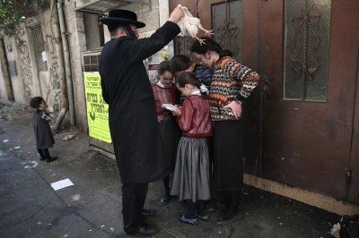
An Ultra-Orthodox Jewish man swings a chicken over his family as they perform the Kapparot ceremony in Jerusalem Photo by Menahem Kahana/AFP (Reprinted from the website of the IB Times)

Kapparot Cermony in Ashdod
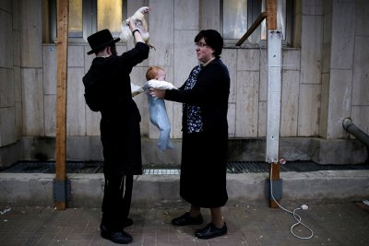
An Ultra-Orthodox Jewish man holds a chicken above a baby in Ashdod, Israel Photo by Amir Cohen/Reuters (Reprinted from the website of the IB Times)
Majority of Israelis to
Fast on Yom Kippur

At about 6 p.m. today silence will fall on Israel, as the Yom Kippur fast begins. Air traffic to and from Israel will halt from 1 p.m. today to about 9:30 p.m. tomorrow and the border crossings to Jordan and Gaza will close down.
Public opinion surveys over the past few years show most Jews in Israel observe Yom Kippur. A survey conducted by the Central Bureau of Statistics found 26 percent of Israeli Jews who describe themselves as “secular” or “not religious” fast on Yom Kippur and 24 percent of them have attended prayers at a shul.
A number of organizations will be holding mass prayers, intended for people who do not frequent shuls on a regular basis, as part of a custom developed in the past years.
Emergency medical services have asked shul managers to make sure a telephone is handy in case of emergency and that a rescue personnel member is close by or among them is pallelim.
Israel’s airspace will close to traffic at 1 p.m. today. Yom Kippur is the only day of the year in which air traffic to and from Israel halts completely. Ben Gurion Airport will reopen for international flights’ landings tomorrow at about 9:30 p.m. and take offs at 10:30 p.m.

Reprinted from the October 11, 2016 website of Matzav.com

Brooklyn torah gazette
For yom kippur 5778
Volume 2, Issue 2 (Whole Number 45) 3 Tishrei 5778/ September 23, 2017
Printed L’illuy nishmas Nechama bas R’ Noach, a”h

For a free subscription, please forward your request to keren18@juno.com
The Solemnity
Of Yom Kippur
By Savta Kops

The spirit of the Day of Atonement finds its supreme voice in shul
Where young and old assemble to join in Divine worship as a tool.
To ask G-d for forgiveness of our sins by prayers, charity and fasting
Confessing the judgments of Hashem are righteous and everlasting.

Yom Kippur is a Day of Judgment which determines the future of every Jew
With a sincere Teshuvah, it can lighten the burden and continue anew.
We concentrate on the sweet chanting of our solemn prayers
Comprehending with sincerity, every word aware that He sees and hears.

Today we pour our hearts out to the A-mighty with prayer and hope
That the path of life being judged and weighed will be painless to cope.
That judgment may be changed, offering a merciful opportunity to all
If we genuinely repent in offering peace and end the delayed stall.

Prayers, fasting and open charity mark this moment to seek forgiveness
And search to rightly adjust their spiritual lives of sins and selfishness.
The crowning movement of Yom Kippur service is the closing of the Gates
With prayers of Neilah that rise up to the Heavens, love to purge hates.

In the Neilah Service we implore G-d to “seal” us in the Book of Life
The final hour of the Day of Judgment we pray for happiness, no strife.
As the sun slowly fades and darkness descends, the Shofar blares
Praying to our Merciful Father to wash away our sins from our solemn tears.
Supplemental stories
For yom kippur 5778
Volume 2, Issue 3 (Whole Number ??????) 10 Tishrei 5778/ September 30, 2017
Printed L’illuy nishmas Nechama bas R’ Noach, a”h

For a free subscription, please forward your request to keren18@juno.com

A High Holy Call for Lox, and Old Hands to Slice It, at Zabar’s
By Corey Kilgannon

Jerry Sze, 63, a retired lox slicer who worked at Zabar’s for 30 years. Mr. Sze returns to his post during the High Holy Days each year, when smoked fish is in high demand. Photo Credit - Alex Wroblewski for The New York Times
Frank Cabrera was tending his garden and enjoying retirement at home in the Dominican Republic when his phone rang.
It was Zabar’s — he was needed at the lox counter.
“Every year I know Zabar’s will call me,’’ Mr. Cabrera, 64, said. “They fly me up, pay for my plane ticket.”
Mr. Cabrera is not Jewish, but he has always observed the High Holy Days by putting in long hours during the mad holiday rush at Zabar’s, that temple of smoked fish on the Upper West Side of Manhattan.
Even after he left the store in 2009, after 26 years, Zabar’s still summons him, and several other seasoned veterans who have a way with a lox knife, out of retirement every fall to satisfy the throngs preparing for Yom Kippur.
Jerry Sze, 63, a lox cutter who worked at Zabar’s for 30 years, lives much closer, in Queens. He too gets the call.
There he was late last week, next to five other lox men wielding long, narrow knives to carve sides of smoked salmon with a surgeon’s precision.
Mr. Sze’s hours vary, but there’s no question about where he stands — the second board, his old position along the counter.
“And I know that when he gets here, there will be 18 people waiting for him,” Scott Goldshine, the general manager at Zabar’s, said. “They all know he slices paper thin.”
Mr. Goldshine showed text messages on his cellphone from customers asking if Mr. Sze would be cutting for the holidays. One was from Tom Paris, 63, who said that after Mr. Sze retired he shifted his allegiance to James Bynum, 50, a slicer with 20 years of experience who learned from Mr. Sze to make each slice of salmon “a perfect, rectangular gem.”
Founded in 1934, Zabar’s is a New York institution, beloved by local residents and tourists alike. And its lox men are its stars. They attract a cultlike following, and for longtime regulars who lose revered cutters to retirement, the holidays are a chance to reunite with their favorites.
The loyalty inspired by lox men runs so deep that many customers bypass the store’s numbered ordering system and wait two hours for a preferred cutter.
In the week before Yom Kippur, Zabar’s can sell up to 10,000 pounds of smoked fish, about four times the amount it sells in other weeks. Crowds descend on the lox counter for the privilege of paying $42 per pound for sliced Nova.
While the store typically has five slicers working at a time, for the holidays, the lox counter is extended several feet and reinforcements are added.
Since slicing at Zabar’s is not an entry-level job — new cutters can train for months before taking an order — Mr. Goldshine said he kept a stable of former employees he could count on.
He also relies on workers like Len Berk, 87, of Pelham, N.Y., who usually works two days a week, to put in more hours.
The passion for lox can be just as intense at other fish mainstays in New York, each of which has its own slicing traditions. At Barney Greengrass, not far from Zabar’s, those practices have been passed down three generations, from Barney to his son Moe Greengrass to his son Gary Greengrass, who now owns the store. Barney had a knack for slicing away from the belly of the fish, so that the darker part of the filet could not be detected in the cut.

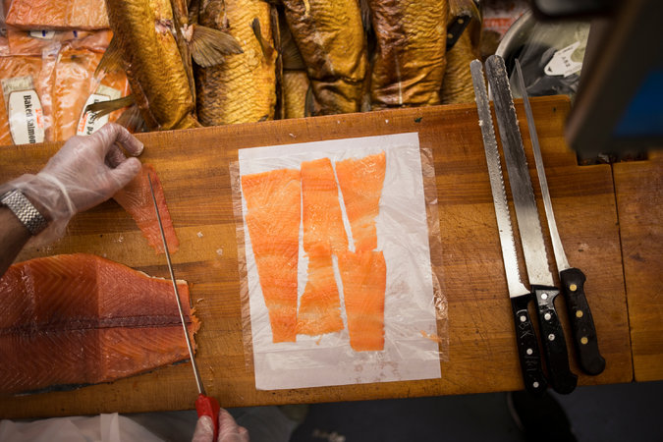
An order of lox at Zabar’s. Slicing is no entry-level job: New cutters can train for months before taking an order, and customers sometimes wait hours for their preferred worker. CreditAlex Wroblewski for The New York Times

Slicing techniques at the venerable Russ and Daughters on Houston Street, which opened more than a century ago, trace back to the founder, Joel Russ, who started the business from a pushcart. They are now refined by Hispanic, Russian and even Nepalese slicers.
“It’s an art form — it’s at the heart of what we do,” said Joshua Russ Tupper, a co-owner and a great-grandson of Mr. Russ.
For decades, the lox slicers at Zabar’s were Eastern European Jews. The counter became so famous that it was portrayed by the artist Al Hirschfeld in a drawing called “Counter Culture,” in which a group of notable people cavort there under the gaze of the celebrated slicer Sam Cohen, who died in 1999.
Now most Zabar’s slicers are Hispanic, but, as Mr. Goldshine joked, “I made half of them Jewish.”
“These are the two sacred spots,” he said, pointing to either end of the long counter, reserved for the most gifted slicers. One end is often held by Mr. Bynum and the other by Mr. Berk, whose spot was occupied for decades by Mr. Cohen.
“I’m the last of the Jewish lox slicers,” Mr. Berk said. “When I’m gone, that’s it.”
Most Zabar’s slicers work their way up from other jobs in the store, but Mr. Berk retired from an accounting career at 65 and persuaded one of the owners, Saul Zabar, to give him a tryout. He was put next to a veteran cutter, David Yan.
“David said one word — ‘watch’ — nothing else,” Mr. Berk said.
“You have to have a steady hand, a sharp knife and enjoy what you do,” he added. “Everyone’s good here, but some are better than others.”
He watched as Mr. Sze cut identical strips so thin that a newspaper could be read through them.
“Jerry can cut every slice the same, that’s his talent,” Mr. Berk said. “Me, I try to cut with panache, with style, with class. I’m constantly looking for the perfect slice.”
Mr. Berk said that years ago he slowly forged a relationship with a particularly fussy lox buyer who would hand back lox that was too salty. “Only after she died did I find out it was Woody Allen’s mother,” he said, adding that he had written a homage to the woman and had asked the actress Dianne Wiest, another of his customers, to give it to Mr. Allen.
On a recent morning, a large crowd milled around the lox counter, with a cluster at one end waiting only for Mr. Bynum. There was Freddie Hancock, 86, a retired agent and the widow of the British comedian Tony Hancock. There was the actor John Pankow.
“This is the mecca” for lox, Mr. Pankow said of Zabar’s. “There’s a poetry to slicing this stuff. It’s a beautiful thing.’’

Reprinted from the October 8, 2016 website of The New York Times. A version of this article appears in print on October 9, 2016, on page A1 of the New York edition with the headline: Lox Masters Answer Annual Call for Perfect Slice.
Why Gangsters Who Broke Every Law Still Went to Services on Yom Kippur
By Robert Rockaway
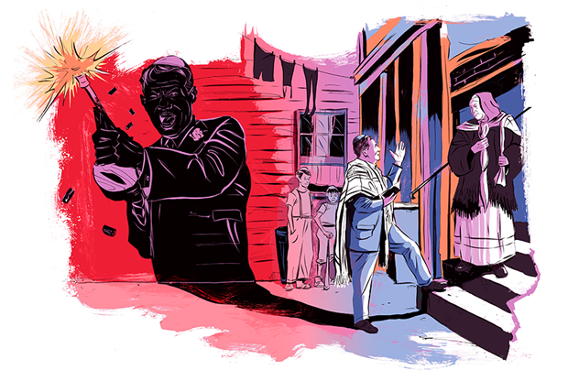

They stole. They murdered. But many Jewish mobsters still saw religious observance as an integral part of their identity.

On Yom Kippur in 1929, Louis Fleisher, Harry Fleisher, and Henry Shorr attended services at Orthodox Congregation B’nai David in Northwest Detroit. The three men—all sterling members of the Purple Gang , Detroit’s mostly Jewish mob—had plenty to atone for: The Purple Gang controlled the city’s illegal gambling, smuggled liquor during Prohibition, and had a hand in most of Detroit’s underworld vice. The gang didn’t hesitate to resort to violence—arson, bombings, and murder—when its operations were threatened. They were reputedly more ruthless than Chicago’s Capone gang.
The three gangsters didn’t notice three other men sitting in the back of the synagogue: G-men disguised in black Hasidic garb who hoped to arrest the three hoodlums after the service. But when the non-Jewish G-men lit up cigarettes during the intermission, not knowing that striking a match or lighting a fire is forbidden on Yom Kippur, their cover was blown and the gangsters got away.
The men of the Purple Gang weren’t the only Jewish mobsters who observed Jewish rituals, even as they committed crimes that broke all of the Ten Commandments, as I discovered while doing research for my book on Jewish mobsters, But He Was Good to His Mother: The Lives and Crimes of Jewish Gangsters . When examining FBI files and interviewing old-time Jewish criminals and their relatives, I found that plenty of Jewish mobsters prayed in synagogue on Shabbat, observed Jewish holidays, maintained religious rituals, fasted on Yom Kippur, and attended Passover Seders.
Sam “Red” Levine provides a singular illustration of this. Levine was New York City gangster Charley “Lucky” Luciano’s favorite contract killer. According to Martin Gosch and Richard Hammer’s 1975 book The Last Testament of Lucky Luciano , Lucky called Red “the best driver and hitman I had.” Red also had another persona: He was an Orthodox Jew. He always wore a kipah under his hat, ate only kosher food, and conscientiously observed the Sabbath. Levine never planned to murder anyone from Friday sundown to Saturday sundown. But, according to Gosch and Hammer, if Levine had no choice and had to make the hit on Shabbat, he would first put on a tallit, say his prayers, and then go and do the job.
Abner “Longy” Zwillman, dubbed the “Al Capone of New Jersey,” reigned as king of the rackets in Newark from the Prohibition era to the 1950s. Next to Meyer Lansky, he was the most prominent Jewish mob boss in America. He reached this pinnacle through brains and violence. Despite his reputation as a ruthless mobster, Zwillman remained sensitive to his Jewish upbringing. Jerry Kugel—whose father Hymie was Longy’s good friend—told me the following story when I interviewed him in 1991:
When Hymie died, Zwillman stood outside and would not enter the chapel where the casket lay. Jerry could not understand this slight. He asked Zwillman why he wouldn’t go into the funeral parlor. Zwillman replied that he couldn’t. Why, asked Jerry. “Because I’m a kohen,” said Zwillman; as a descendant of the priestly class, he was forbidden to come into contact with a dead body.
There are other examples from all around the country of Jewish gangsters obeying certain Jewish laws. How does one explain hoodlums, killers, vicious and violent men adhering to certain biblical injunctions? What about the Sixth Commandment, “You shall not murder,” and the Eighth Commandment, “You shall not steal”? Why this paradox in their lives?
The Purples and most Jewish gangsters during Prohibition were the children of Eastern European Jewish immigrants who had come to the United States between 1881 and 1914. The mobsters had been born in America or came as kids. According to Arthur Hertzberg, in his 1997 book The Jews in America, most of their parents had not been part of the religious elite of their communities—the more pious and religiously Orthodox Jews heeded their rabbis’ warnings that America was a trayfe medina (non-kosher land) and stayed behind in Europe. Nonetheless, the Jews who did immigrate came from places where the Jewish religion and Jewish traditions persisted as an integral part of the milieu. Most of the immigrants may not have been Orthodox according to Jewish law, but they maintained traditional Jewish religious patterns and brought these practices with them to America. Out of habit, a non-believing Jew might still observe the dietary laws at home, occasionally go to synagogue, and say kaddish for departed parents. These immigrants practiced what sociologist Charles Liebman, in his 1993 book The Ambivalent American Jew, called a kind of Jewish folk religion.
The Jewish mobsters grew up in these traditional homes in Jewish neighborhoods that were infused with folk Judaism, such as New York’s Lower East Side, Chicago’s West Side, and Detroit’s East Side. And like many of their non-criminal peers, some of them continued these behavioral patterns into adulthood. Jewish ritual remained an indelible part of their identity, a part of who and what they were.
Perhaps the greatest influence on the “Jewishness” of these men were their mothers. Many of the major Jewish mobsters, including Meyer Lansky, Dutch Schultz, Lepke Buchalter, Longy Zwillman, and Mickey Cohen, as well as those I interviewed, revered their mothers. Family and friends recounted to me how these men doted on their mothers and treated them with utmost kindness and respect.
In the 1979 book Meyer Lansky: Mogul of the Mob , Lansky told Israeli journalist Uri Dan how his mother “hated to see us go hungry, and she was always ready to give us her share because, like every Jewish mother in the neighborhood, she gladly sacrificed herself for her children.” These mens’ relationship with their fathers was more problematic. Part of this resulted from the fathers never reconciling to their sons’ criminal way of life.
Jewish mothers sacrificed for their children, but they expected something in return. One of their requests was that their sons sei Yidden (be Jews) and maintain a connection with the Jewish community. At least during their mothers’ lifetime, a goodly number of these tough Jewish mobsters obeyed. Detroit mobster Harry Kasser told me in a 1986 conversation that he attended synagogue on the High Holidays solely to please his mother. All of the old-time Jewish mobsters I interviewed could speak Yiddish and practiced some of the Jewish customs. Most of their closest friends and associates in crime and outside of crime were Jews; they married Jewish women (at least their first wives) in ceremonies conducted by rabbis; they contributed to Jewish causes; they attended synagogue on the High Holidays; and they circumcised their sons and made bar mitzvahs.
Another factor contributing to the paradox in these mens’ lives was their ability to separate what they did to earn a living—their “business” lives—and the way they behaved in their personal lives. Behaviorists refer to this as “compartmentalization”: being able to act one way in the private world and another way in the public sphere, even if the result was blatantly inconsistent behavior. This paradox was expressed to me by a lawbreaker named Myron (he asked that I not use his family name).
For years the FBI tried and failed to obtain a conviction against him. The Internal Revenue Service succeeded, however, and Myron ended up going to prison for income tax evasion. When we spoke in 1991, I asked him if he wanted his son to follow in his footsteps with all the dangers it entailed. He replied: “I would say to him that I chose my life, you go choose your life. The only thing is that whatever you choose to do, I would say to him, you gotta put on tefillin every morning, you gotta eat kosher meat, and you have to maintain certain principles.”
Throughout their lives, Jewish mobsters remained products of their homes and the environments in which they grew up. Whether they believed in G-d or not, in adulthood they continued the Jewish traditions they learned as children. No matter how vile their later behavior, in each of these men there remained a pintele Yid, a spark of Jewishness. Meyer Lansky, the alleged godfather of Jewish organized crime, told me in 1980 that he was a non-believer. Yet he maintained his membership in a synagogue, regularly contributed money for its upkeep, and attended services on the Jewish holidays.
Labor racketeer Lepke Buchalter displayed similarly paradoxical behavior. He commanded an army of gangsters who terrorized New York’s garment industry. His gang’s weapons were destructive acids, bludgeons, blackjacks, knives, fire, ice picks, and guns. At his peak, he controlled a wide assortment of businesses and unions including the bakery and pastry drivers, the milliners, the garment workers, the poultry market, the taxicab business, the motion picture operators, and the fur truckers. Despite the murderous brutality he exercised in his business affairs, he was a considerate son and a doting husband and father. He described himself as a Jew, contributed money to his mother’s synagogue, attended High Holiday services, and, according to the FBI, led a quiet home life.
The paradox sometimes lasted till the end of the mobster’s life. Harry “Gyp the Blood” Horowitz was a vicious brute and killer of enormous strength, who thought nothing of breaking a man’s back for fun. In 1914, he and three accomplices were convicted of murdering the gambler Herman Rosenthal and were sentenced to death. According to the April 18, 1914, edition of the Forward, after being strapped into the electric chair at Sing Sing, Gyp recited the Shema. When he finished, a jolt of electricity surged through his body, killing him instantly. One of his accomplices, Louis “Lefty Louie” Rosenberg, died in the electric chair holding a Chumash.
Later in life many of the Jewish mobsters strayed far from the traditions of their youth. But almost all of them received Jewish burials at their death. Despite the brutal and illegal nature of the lives they led, at their demise many of these underworld figures still remained tied to their families, their people, and the Jewish tradition.

Reprinted from the October 11, 2016 email of Tablet Magazine.

Battle for Kapparos is as Important
As Battle for Shechita and Bris Milah
By Rabbi Pini Dunner
Over the past few months, animal rights activists in the United States have focused their attention on the pre-Yom Kippur custom of “kapparot.” Here in Los Angeles, protesters disrupted a kapparot gathering at the Hebrew Discovery Center, run by Rabbi Netanel Louie. Meanwhile, in New York, aggressive protesters picketed kapparot sites across the city. At one location in Crown Heights, the demonstrators, frustrated at their inability to prevent kapparot, began chanting, “Animal holocaust” and, “Murderers: Wake up, you’re oppressed!”
There is no question that kapparot is a controversial custom, even among the most traditional Orthodox Jews. Carried out before Yom Kippur, the ritual involves a live chicken being waved around a person’s head, as he or she recites a formula symbolically removing their accumulated sins and transferring them to the chicken. The chicken is then killed and given to the poor.
Kapparot originated in the Babylonian Jewish community approximately 1,500 years ago, and has been fiercely debated by rabbis ever since. Senior rabbinic authorities dismiss kapparot as a paganistic rite that diminishes the seriousness of the High Holidays by giving the impression that by uttering a few words over a chicken, one can circumvent the entire repentance process.
Later rabbis were concerned that the huge numbers of chickens requiring ritual slaughter in such a short period of time would inevitably lead to some not being slaughtered correctly. They argued that the danger of feeding poor Jews with non-kosher chickens was surely a far greater concern than a questionable custom not prescribed by the Torah or Talmud.

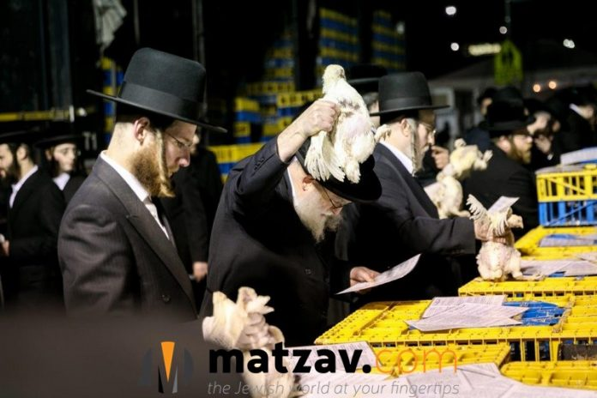

Like the Roman Colosseum, the UN has become an outlet for outlandish escapism and diversion from real problems facing the…
As a result of these objections, an alternative kapparot method using coins instead of chickens became increasingly popular. Indeed, the vast majority of those who perform kapparot today use coins, and the money is later distributed to charity. My own German Orthodox tradition is not to do kapparot at all. Although I was aware of the custom growing up, my first exposure to it — in both chicken and coin form — was when I went to post-high school yeshiva.
At our synagogue in Beverly Hills, we held an orderly kapparot session on the morning before Yom Kippur, using half-dollar coins. The issue of the animal activist protests came up, but there are surely those in the Orthodox community who quietly sympathize with the protesters, and agree that waving a chicken over your head in a symbolic ritual is tantamount to animal cruelty — something that is strictly forbidden by Jewish law. It has also emerged that many of the chickens never make it to the poor; instead they are abandoned in trashbags as everyone rushes to get home and prepare for Yom Kippur.
So what are we to make of the attempts to halt this practice in the United States? In August, a state lawsuit — “United Poultry Concerns vs. Bait Aaron, Inc.” — was filed in California to prevent any group, including Hebrew Discovery Center, from holding kapparot events; the suit was ultimately dismissed.
A federal lawsuit — “United Poultry Concerns vs. Chabad of Irvine” — met with greater success. Filed on September 29, it resulted in a temporary restraining order against Chabad of Irvine’s kapparot plans, with the order being lifted with only hours to spare before Yom Kippur began.
The attorney acting for Chabad of Irvine, Hiram Sasser, pointed out that kapparot “is protected by the First Amendment, so the temporary restraining order should never have been issued.”
He’s right. The erosion of First Amendment rights in this country is something that needs to ring alarm bells for all of us, even if the target happens to be kapparot. While I cannot condone the wanton abuse of animals, I also know that every chicken we eat has gone through a disorientating process leading up to its death. But the law is followed to minimize any suffering; that is how we can eat chicken. If kapparot is done in such a way that it minimizes any suffering to chickens, and those who do kapparot ensure that the chickens are subsequently used for charitable purposes, even though I do not personally participate in kapparot, I will fiercely advocate on its behalf to any detractor.
As to most of the detractors — their objection is not against kapparot; it is much broader than that. Using animal rights as a pretext, their real objection is to religious individuals carrying out hallowed customs that harm no one while giving meaning and depth to countless lives.
Kapparot is just the thin end of the wedge. Shechita (ritual butchering) and circumcision are next, and I have no question these warped individuals also wish to impose their skewed values on our synagogues and day schools by insisting that we adopt practices to accommodate contemporary human rights ideals and social policies that run counter to our faith.
In this week’s Torah portion, the language is very flowery and poetic. In one pasuk (verse), the Torah refers to those who rebel against G-d as “a nation that is vile, and unwise.” These two definitions seem completely unrelated. There are those who rebel because they are vile, and there are those who rebel because they are unwise. Why the need for both?
Commenting on this phrase, the prolific 19th century Polish rabbinic leader, Rabbi Yosef Shaul Nathanson, said: “If the nation were wise but vile, perhaps we could reason with them. If the nation were foolish but righteous, perhaps we could educate them. But when the nation is both vile and unwise, the cause is lost!”
Those who oppose kapparot, and whose hatred of rites and ritual transcends common sense, are immune to both logic and education. Our only chance of victory is to recognize them for what they are. We cannot give an inch in the battle for our rights to religious freedom. The battle for kapparot is as important as the battle for shechita and circumcision.

Reprinted from the October 16, 2016 website of Matzav.com Republished from the Algemeiner Journal.

About New York

A Raw Deal for Chickens,
As Jews Atone for Sins
By Jim Dwyer

A hen squirmed in Joel Lubin’s hands, but he held on and raised it over the head of his wife at noon on Thursday, as they stood on a sidewalk in the Williamsburg section of Brooklyn.
As Mr. Lubin turned the bird in three small circles over her head, his wife read from a laminated card. In front of her was a double-wide stroller with two children on board. Behind a barricade a few feet away were about 100 plastic crates full of live chickens. It may never be a good week to be a chicken — that is a deep, deep question, beyond the remit of this column — but let us say that the first days after the Jewish New Year are a particularly bad time to be one in parts of Brooklyn.
Between Oct. 4, the end of the Rosh Hashana observance of the new year, and Yom Kippur, the day of atonement starting the night of Oct. 11, an estimated 50,000 chickens will be sacrificed in Brooklyn as part of a penitential ritual performed by some Hasidic Jews.
The practice, called kaporos or kapparot, is meant to transfer a person’s sins to the chicken. “If you’re going to die during the year, maybe the chicken will die instead,” Mr. Lubin said. The chicken he rotated over his wife’s head was brought into the Cohn Live Poultry shop on Flushing Avenue, where it was slaughtered, made kosher and packed on foam butcher trays. “It goes to the poor,” Mr. Lubin said of the chicken.

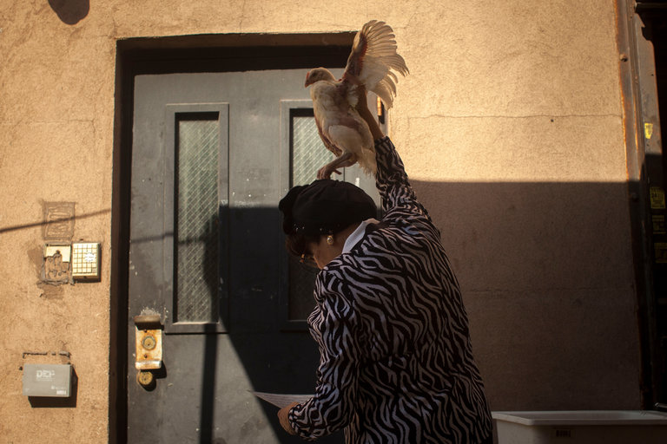
A Hasidic Jewish woman performed a penitential ritual, meant to transfer a person’s sins to a chicken, by holding the bird over her head on Thursday. Photo Credit - Dave Sanders for The New York Times

Mrs. Lubin, who declined to provide her given name, had enlisted her husband to handle the bird. “I really don’t like touching animals,” she said. “You can have someone else do it, but you say the prayer.”
To meet the demands of penitents in Brooklyn, slaughter operations are set up every year in parking lots and other open spaces, often run by congregations and other organizations to raise funds.
Last year, animal rights activists sued New York City, arguing that it was not enforcing health, sanitation and other regulations around the practice. A judge ruled that there was no clear evidence of a public nuisance. A congregation in a Detroit suburb won a case last year that allowed it to proceed with kaporos. Two similar suits are pending in Southern California. Critics also say that the chicken ritual is tradition, not holy law, and kaporos can be carried out satisfactorily by donating money.
Some kaporos practitioners swing the birds overhead, gripping the wings or legs, but the people outside the Cohn store on Thursday kept a firm handle around the midsection.
Because Cohn sells live poultry year round, the business carries out the slaughter and butchering with a minimum of gore.
At a booth set up in the street, people pay $17 for a ticket marked “male” or “female” and then pick up their bird in a canopied area. Women are issued hens, and men get roosters, explained Rifki D., who did not want to give her last name.
“If you’re pregnant, you take an extra one,” she said. “For yourself you take a girl chicken, then you take a boy chicken in case that’s what you’re having.”
The chicken becomes not only a surrogate for life and death, but for less mortal matters. “There are some who might give it a light kick,” Rifki D. said. “The thinking is, if I’m going to be kicked during the year, let it be the chicken.”
Included in the lawsuit filed last year were pictures of chicken carcasses that had been disposed of in the regular city garbage, but it seems that birds typically are used for food. “We are all here for a purpose, and the chicken is here for a purpose,” said Yossi Cohn, 32, grandson of the founders of the poultry store. “We eat them.”
The early days of kaporos are dominated by women, Mr. Cohn said. The men want to wait until the last moments before Yom Kippur to carry out the ritual, hoping to clean up as many sins as possible before atonement. The store will remain open all night on Monday to accommodate those coming in the final hours. “The men have more sins,” Mr. Cohn said.
Many people purposely leave their chickens with the store, knowing that they will be given to people in need or to organizations that could use them.
So maybe not a good week to be a chicken, getting stuck with human failings. But not so bad for hungry people without money in their pockets. Just inside the door to the store, a shopping cart was filled to the brim with plastic-wrapped chicken parts. The stickers listed the price: Free.

Reprinted from the October 6, 2015 website of The New York Times. A version of this article appears in print on October 7, 2016, on page A20 of the New York edition with the headline: When Atonement Is a Raw Deal for Chickens.

Days of Davening
By Larry Gordon

We just completed two days dominated by and devoted to essentially one thing—davening.
Most of us have done this for years, if not decades, and though it is repetitious, it is a way in which we are able to chart our growth as Jews committed to the unique ideal of crafting a special relationship with our Creator at this particular time of year.
Rosh Hashanah is a day of judgment as well as recollection and remembrance. We look back while also looking ahead. Fresh from sitting in shul for a good part of two days, I can report on several things about the experience. Actually, because of a recent conversation with Cantor Joel Kaplan of Congregation Beth Sholom in Lawrence several days before yom tov, I found myself focusing on the singing, or what Cantor Kaplan calls the essential nusach ha’tefillah.

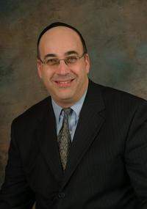
Cantor Joel Kaplan

May Include Shlomo Carlebach Compositions
I took special note of the melodies that provided the underlying support of our tefillos. Some were older than I could remember. They may have dated back many decades, possibly hundreds and in some cases a few thousand years, if you can imagine that. And then there were the prayers sung to newer and more recently written compositions which may include Shlomo Carlebach compositions as well as those composed by other songwriters over the years.
Cantor Kaplan is part of a new initiative being advanced by the Orthodox Union to educate the davening masses about the tradition of nusach—primarily the singing—as a way of preserving our ancient rituals. “Nusach ha’tefillah is how we daven to Hashem. We thank Hashem and make requests multiple times a day, as we rise in the morning, perform our daily ablutions, eat, travel, eat again, work, daven, snack, work, daven, eat again, learn, prepare for bed . . . And beseech Him to keep us all safe and secure,” says Cantor Kaplan.
These Tefillos are Ever More Crucial
“In these days of great peril for Am Yisrael and medinas Yisrael, these tefillos are ever more crucial. Could we envision a surgeon performing surgery without knowing anatomy? Or an attorney arguing his client’s case without knowing the law underpinning his position? Then we too must know how to daven to Hashem utilizing the acceptable nusach,” he adds.
He suggests that incorporating more contemporary music into our shul service runs the risk of somehow diluting or even severing our special connection to tradition, unless the songs were incorporated in the places where there is that flexibility, and not jettisoning the nusach ha’tefillah of generations.
As I focused on this theory over the just-concluded Rosh Hashanah observance, I thought about this hypothesis. In my shul, as in others I’m sure, where there is no dedicated or professional chazzan, so to speak, I could not help but take note of the songs that were new and the way in which they contrasted with the tunes that conjured up memories of decades ago, davening in shul as a child or teenager alongside my father and brothers.

Traditional Songs Brought an Emotional Warmth
Actually, as I davened this year, I felt that the newer material was OK, but that the songs that were traditional brought an emotional warmth to the fore and even a tear, as my mind wandered back to the good old days in shul.
At some point in the davening over Rosh Hashanah, it occurred that some of the melodies accompanying these words were sung by our great-grandparents and generations before them, dating back further than we can picture under what must have been circumstances and life far different than we are living here today.
Words and music feature a mystical if not magical combination. While words of the davening and their meaning are an anchor, the music or the tunes have this uncanny ability to traverse time, and sometimes take us on a trip through our personal as well as communal history.

The Maharil Decreed that there
Are Rules that Must be Followed
Cantor Kaplan adds: “The Maharil, Rabbi Jacob Möllin (1365–1425 CE), decreed that there are rules, parameters, and musical guidelines that must be followed and that dictate the use of any and all melodies in our tefillot. This was codified as part of our halachic tradition. One should not digress from the customs of the place, even with regard to tunes and piyutim that are used. The Rema codified this ruling of the Maharil as normative halachah.
“Some of these nigunim are described as miSinai, not because we have actually traced their origin back to Sinai, but because of their authenticity and tradition. Yet, with the advent of contemporary music into our society and even into our shuls and our davening, and the absence of resources through which the average layman can learn the authentic melodies, nusach has slowly but surely been disappearing from our shuls.
It is not that singing a pop tune is bad; it might be quite sing-along-able. Shlomo Carlebach’s melodies are quite ‘catchy’ and uplifting. But they need to be utilized—and I utilize them frequently—in the places in the davening that are not already ‘reserved’ by the traditional nusach ha’tefillah. For the most part, for example on Rosh Hashanah, V’chol Maaminim, Hayom Haras Olam, Areshes Sefaseniu, Heyei im Pifiyos, V’yesau, to name a few, are open to almost any melody—Carlebach included. What is important is that where the traditional nusach ha’tefillah needs to be used, the shaliach tzibbur, not only on Rosh Hashanah and Yom Kippur but throughout the year, knows the nusach and uses it.

Questions About What’s
Appropriate on Kol Nidre Eve
“So, if you came to shul on Kol Nidrei eve, and the ba’al tefillah got up for Kol Nidrei, and sang his own composition, would that be acceptable? Or if someone went up to lein, and substituted his own set of trop, would that be acceptable?”
We need to preserve the nusach ha’tefillah in its place, and let the contemporary tunes “do their thing” in the many places in the davening where they can be used. And like Joel says, you can rest assured that regardless of where you daven over the yamim tovim or on any Shabbos, if your ba’al tefillah or chazzan used his own composition next Tuesday night at the Kol Nidrei service, there would be some serious objections if not an uproar, Yom Kippur notwithstanding.
At a presentation at Congregation Keter Torah in Teaneck two weeks ago, the OU sponsored a seminar on this exact subject with Cantor Joseph Malovany of the Fifth Avenue Synagogue taking his audience on a tour of the science behind the davening.

The Common Denominator the Crosses the Great Divide
“Kol Nidrei is a cold legal document,” Malovany says, and he adds that it is the almost ancient traditional tune that cannot be communicated here on paper that injects the service with meaning and brings the davening to life. For many Jewish communities over the vast spectrum of Jewish life, Kol Nidrei and the song that it is sung to is the common denominator that crosses the great divide between our diverse communities over their locales near and far.

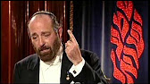
Cantor Joseph Malovany of the Fifth Avenue Synagogue

One of the purposes of this OU initiative [www.ou.org/community/programs/nussach-hatefillah/] is teaching the traditional music to the non-chazzanim, so to speak, to make certain that members of each community have an awareness and knowledge of the deep and meaningful history of our shul services on both Shabbos and yom tov.
Frankly, we are probably not even aware of the depth of the history of the marriage between the words and music of our tefillos. There is little question that we take them for granted, whether it is the high point of Kol Nidrei or the many tunes that are identifying points that we recognize in the course of our Rosh Hashanah and Yom Kippur davening.
While the words are the elixir and formula of success for a fulfilling and meaningful davening, where would we be without the music that accompanies them? There are many distractions in the course of these long days in shul. There is the aching feet from standing through the longest Shemoneh Esreih of the year, and the back pain that comes with both too much standing and too much sitting.
But then there is the music that brings it all home and makes the difference. The words and the tunes often lift us up, take us back in time, touch our neshamos, and provide us with the recipe and ingredients for a successful davening and a good and sweet new year ahead.

Reprinted from the October 7, 2016 edition of the 5 Towns Jewish Times.

